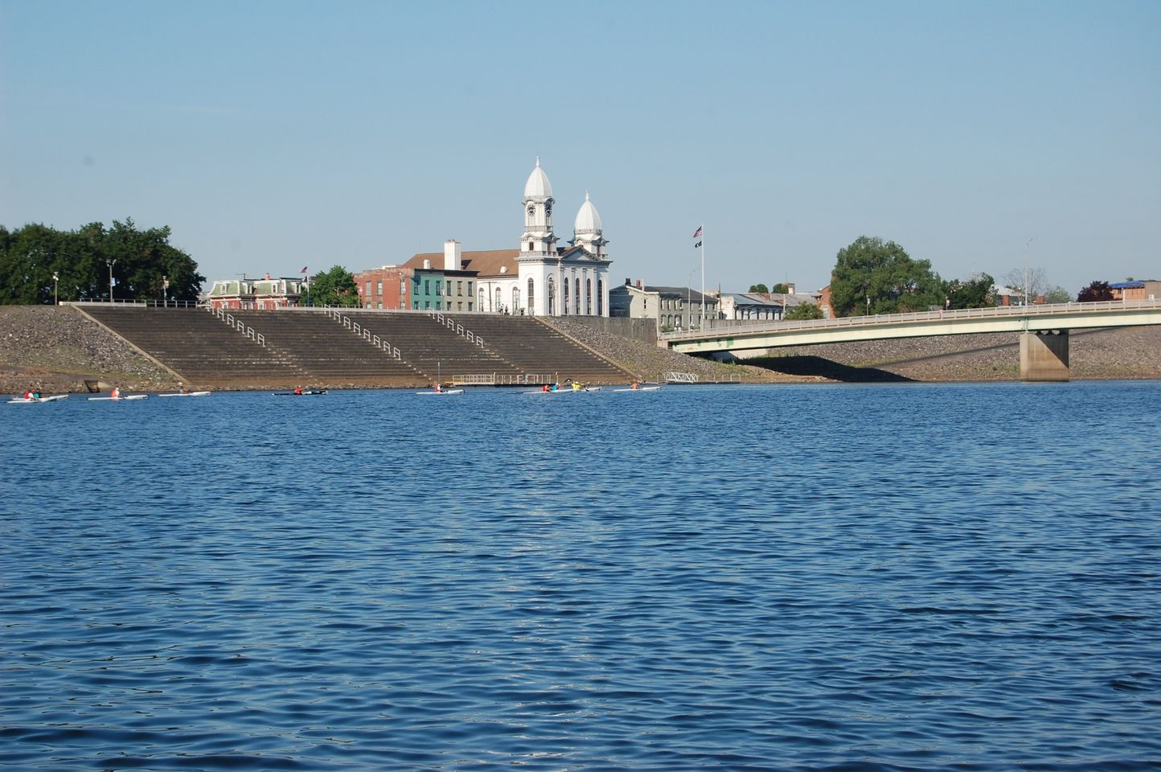

2026
U.S.C.A. NATIONAL EVENT SCHEDULE

August 6th to August 9th, 2026

Sponsored by Clinton County Recreation Advisory Committee

Located at 316 Coudersport Pike, Lock Haven, PA 17745

VISIT OUR FACEBOOK PAGE:
2026 USCA NATIONALS LOCK HAVEN, PA

Important Information for the 2026 U.S.C.A. National Championships

All participants must be a 2026 USCA member and have their membership number available for registration. You may renew your membership on-line, http://www.uscanoe.com/join-usca. You may also mail your membership application with payment to:
Lynne McDuffie, Membership Chair
410 Cockman Road
Robbins, NC 27325

Email address: llmcduffie@gmail.com

You may renew your membership on site; however, we would encourage you to renew your membership before the event.

Registration

You may register for the event on-line, please fill out the attached registration form and email to debscooking@verizon.net.

Our credit card link is https://certifiedpayments.net/index.aspx?BureauCode=1408046

Please list your payment confirmation number on the registration form. If you are paying for a person other than yourself, please include the competitor’s name on the registration form.

Please see our registration form for complete credit card payment details and feel free to contact me with any questions. Email address is debscooking@verizon.net

You may also print the form and complete manually. Please send the form along with a check made payable to Clinton County Recreation Advisory Committee to:

Deb Glover
619 Park Avenue
Lock Haven, PA 17745

A free T-shirt and goodie bag for participants whose registrations and payments are received by July 1, 2026, for marathon/youth sprints. We will be accepting orders for additional events shirts (adults only). Orders and payments must be received by July 1, 2026. You may place your order with your registration form for additional shirts.
Waiver/Release of Liability form must be completed and signed by each participant at check-in.
Children under the age of 18, must have a parent or guardian co-sign.
Age Groups- The following age groups will apply for all marathon classes except for those that are stated otherwise. In tandem events (C2 or K2), the team’s age is determined by the younger of the two paddlers in adult classes. In youth classes, the team’s age is determined by the older of the two paddlers.

Adult (Age on Race Day) Youth (Age on 01/01/2026)

18-39 Adult 18-39 Youth 5-7
40-49 Master Youth 8-10
50-59 Senior Youth 11-12
60-64 Veteran 1 Youth 13-14
65-69 Veteran 2 Junior 15-17
70-74 Grand Veteran 1 Adult (18+)/Youth (5-14)
75-79 Grand Veteran 2 Adult (18+)/Junior (15-17)
80+ Grand Master Veteran

Boat Jigging—The USCA Technical Inspection Station will be available starting the afternoon of Thursday, August 10th for those wishing to have their boats “pre-jigged.” On Friday and Saturday, the station will be open following the race until 2:00 pm. Times are subject to change and will be posted at Race Headquarters and on our Facebook Group page. Boats that are pre-jigged will receive an inspection sticker which will speed their passage through technical inspection following the races.

SAFETY
Attendance at pre-race meetings is mandatory.

A US Coast Guard approved PFD must be in possession of each contestant and a sound producing device such as a pea-less whistle which meets USCG requirements. Each boat must carry this device, and the device should be securely affixed to a PFD or the boat in a manner which allows quick access in a personal emergency.
US Coast Guard approved PFD must be always worn by all non-swimmers and by people aged 5-14 on the water and by all contestants in the Youth classes. Inflatable PFDs shall not be worn by non-swimmers and by all people under the age of 16.
The Competitor takes full responsibility for selection and use of the PFD that meets all federal, state and local requirements. In the case of minors, this responsibility rests with the competitor’s guardian.

Lightning Safety: Before a race has started, if thunder is heard and/or lightning is seen, or a lightning detector indicates an approaching thunderstorm, the racers, race helpers, and spectators shall take proper shelter and wait at least 30 minutes after hearing the last thunder. Once a race has started, if lightning is seen, you count the time until you hear thunder. If this time is 30 seconds (6 miles) or less, or if you do not see the lightning, but hear loud thunder; get off the water immediately and seek proper shelter. The race is considered officially stopped at that moment in time. This is a weather emergency and race clocks will be stopped. The order of the paddlers on the racecourse at that instance will be considered their placement in the finishing order, based upon discussion with the racers and race officials at the finishing area. Thirty minutes after hearing the last thunder, the racers may proceed down the racecourse.
Detailed information will be provided at the pre-race meeting.

Traveling Trophies may be delivered to Race Headquarters upon arrival to check-in. Please make sure these trophies are checked in by a USCA Official.

Friday Night Dinner: August 7, 2026
Price $12.00 a ticket for adults (16 years old or older)
Children ticket price $8.00 (ages 9 to 15)
Children 8 years old and under- donation would be appreciated
Location is Dunnstown Fire Hall from 5:00-7:00.
Address: 119 Woodward Avenue, Lock Haven, PA 17745
Dinner will include spaghetti, meatballs, roll, dessert, and drink
U.S.C.A. Semiannual Meeting: Friday, August 7, 2026, at 7:00 pm. Location will be Dunnstown Fire Hall.

BIATHLON- August 5th at 5:00
5K paddle starting at the Lockport Boat Launch, and a 5K run. Individuals or teams are welcome. Follow our Facebook page for more information. Everyone is welcome to participate.

August 5th-Tour of the River
We will have a free tour of the river. The tour will be a 7-mile leisure paddle. The tour will cover part of the racecourse. Paddlers will have the opportunity to ask questions about the course. Tour will start after Biathlon awards.

Open registration will be held this day from 4:00 pm to 8:00 pm. Paddlers can check-in, register, sign waivers forms, and receive their packet of information.
August 6, 2026---Youth Sprints
We will open registration for the youth at 7:45 am and close registration by 9:15 am. We will have the National Anthem and a pre-race meeting for all youth directly after the close of registration.
We do encourage youth to register before our event.
Waiver forms can be signed on August 5th at Open Registration or on August 6th.
Awards ceremony will be held at the Lockport Boat Launch shortly after the last race.
Youth Sprints- All Youth/Junior Sprint events will be 250 meters. A youth paddler may enter one of each of C1, C2, Mixed, K1, K2 and SUP for a total of six (6) events. Adult paddlers in the Adult/Youth-Junior Sprints must be 18+ years of age as of race day. Adults may paddle in more than one age group of Adult/Youth events and Adult/Junior events.

The sequence of Youth Sprints are listed below.

1. C1 Youth (5-7) | 15. K1 Woman Junior (15-17) | 29. C2/K2 Man/Junior (15-17)
2. C2 Youth (11-12) | 16. C2 Men Junior (15-17) | 30. C2/K2 Woman/Youth (5-7)
3. C1 Youth (8-10) | 17. C1 Woman Junior (15-17) | 31. C2/K2 Woman/Youth (8-10)
4. K1 Youth (11-12) | 18. C2 Boys Youth (13-14) | 32. C2/K2 Woman/Youth (11-12)
5. C2 Youth (5-7) | 19. K1 Boy Youth (13-14) | 33. C2/K2 Woman/Youth (13-14)
6. K1 Youth (8-10) | 20. C1 Man Junior (15-17) | 34. C2/K2 Woman/Junior (15-17)
7. C1 Youth (11-12) | 21. C2 Girls Youth (13-14)
8. C2 Youth (8-10) | 22. C2/K2 Mixed Junior (5-17)
9. K1 Youth (5-7) | 23. SUP Unlimited Man (5-17)
10. C1 Girl Youth (13-14) | 24.SUP Unlimited Woman (5-17)
11. K1 Man Junior (15-17) | 25. C2/K2 Man/Youth (5-7) | Youth Marathon
12. C2 Women Junior (15-17) | 26. C2/K2 Man/Youth (8-10) | C1 Youth 5-7, 8-10, 11-12
13. K1 Girl Youth (13-14) | 27. C2/K2 Man/Youth (11-12) | K1 Youth 5-7, 8-10, 11-12
14. C1 Boy Youth (13-14) | 28. C2/K2 Man/Youth (13-14)

Orienteering Event—Will begin at 3:00 pm –Details to follow, for more information visit our Facebook page: 2026 USCA Nationals Lock Haven, PA
Daily Registration
August 6th– August 8th – Open registration from 3:00 pm to 5:00 pm.

During this registration, you may register to compete in an event for the next day. You may also make a change to a previous registration, for example, add a race or change a race. No Same Day Registration will be permitted for marathon events.
Marathon Events—August 7th to August 9th

Time and Location to pick up Boat Number
Time: 7:45 am to 8:45 am
Location: Lockport Boat Launch
National Anthem and Mandatory Pre-race meeting 9:00 am
Races will begin at 9:30

Please note: Depending upon participation, we may have a staggered start. This will be determined closer to event.

Awards
The awards ceremony will be held each day at the conclusion of the event. We will compute the times and have the awards as soon as possible. The ceremony will be held at the Lockport Boat Launch.

Marathon Schedule of Events for 2026
Friday – August 7, 2026
C2 Mixed
C2 Standard Mixed
C2 Man/Junior (C2M/Jr)
C2 Woman/Junior(C2W/Jr)
OC2 Mixed
K1 Touring Woman
K1 Sea Kayak Man
K2 Mixed
Short Course
C2 Man/Youth (C2M/Y)
C2 Woman/Youth (C2W/Y)
C2 Mixed Junior (C2Mx Jr)
Saturday - August 8, 2026
C1 Woman
C1 Woman Stock
OC1 Woman
C2 Men Open
C2 Standard Men
OC2 Men
K1 Unlimited Woman
K1 Touring Men
K2 Men
Short Course
C1 Woman Junior & Barton Youth Award
K1 Woman Junior Unlimited & Barton Youth Award
C2 Men Junior
SUP 14 Men
Sunday – August 9, 2026
C2 Women
C2 Standard Women
OC2 Woman
C1 Man
C1 Stock Man
OC1 Man
K1 Unlimited Man
K1 Sea Kayak Woman
K2 Women
Short Course
K1 Unlimited Man Junior & Barton Youth Award
C1 Man Junior & Barton Youth Award
C2 Women Junior
SUP 14 Woman

